City Community Updates

* COVID

**Current Case Numbers:**

Yamhill County has had **1977 positive COVID cases** reported to date (up 209 from 1768 this time last week). There have so far been 19 deaths. [Here is the link](https://linkprotect.cudasvc.com/url?a=https%3a%2f%2fhhs.co.yamhill.or.us%2fpublichealth%2fpage%2fcovid-19-coronavirus-information&c=E,1,nvAToR93EPqdAmnrXMTzxA2lopS2_51M0VgMZF0xWSCRAHSd9Ii1jN1_oZTz_lUl-BAxl4gektAFguLOwPBdJIGm1915uAX4pH1H5Oo3CsLrcDfdvey59w,,&typo=1) to the Yamhill County COVID webpage. [This is the biweekly OHA Epidemic Trends and Projections Report](https://linkprotect.cudasvc.com/url?a=https%3a%2f%2fwww.oregon.gov%2foha%2fPH%2fDISEASESCONDITIONS%2fDISEASESAZ%2fEmerging%2520Respitory%2520Infections%2fEpidemic-Trends-and-Projections.pdf&c=E,1,IZoHDbVeSLsLBUuyhNt063Qhykd9KretdmBW_Qms-D9H9ffdmFy-LbIWqAywuWDuqn0CIyTPe_DpZrANHYFsge3icBrCG9xTt-vM4bs7ND2kxpi0bQ,,&typo=1) (updated every three weeks, last updated 12/2).  Below is a graph of data taken from the [OHA’s Weekly School Metrics Data Report.](https://linkprotect.cudasvc.com/url?a=https%3a%2f%2fwww.oregon.gov%2foha%2fPH%2fDISEASESCONDITIONS%2fDISEASESAZ%2fEmerging%2520Respitory%2520Infections%2fWeekly-County-Metrics.pdf&c=E,1,mHqnb1D_x26gGfHNxPUyCdOZNuFgZbWa_-U8vWeoaSA2QzvYZyodbtd1xKGZtTHsAgue4TfGBJETShE3WCvvc4kKN0zQ37Z6HH_StHsfCYVZvTnG4t22ZkdUuQ,,&typo=1)

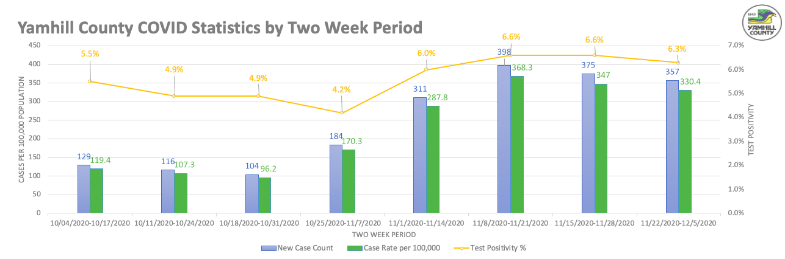

* Police
  + **The Carlton Police Department, in conjunction with city hall staff, has facilitated the installation of a 911 call box on the front of city hall just to the right of the main doors.  The call box is for citizens to have the ability to access 911 (YCOM dispatch) in the event of an emergency.  When an individual has an in-progress emergency, all they must do is open the call box and pick up the phone, which automatically calling 911.**

**This box will be monitored by camera 24/7.  There will also be a sign to identify penalties for misuse of the 911 call box.**

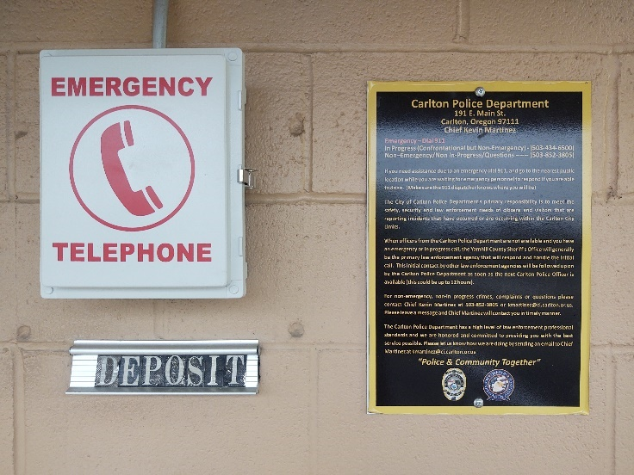

* Public Works
  + **Hawn Creek Playground Update-Equipment**
    - **The curb will be poured Monday December 14th, and walkway will be formed the following week. The chips for the fall cushion will be installed by January 15th.**
* **Wennerberg concrete contractor bids for the playground will go to city council in January.**
* Finance and Administration
  + **In house fieldwork for the City’s annual Audit is complete.**
  + **Santa Box Success: All children who leave a return address will receive a response from Santa.**

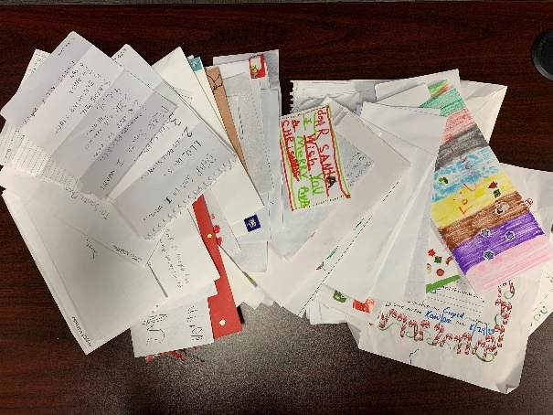

* + **Kayla Baker’s last day is the 16th of this month. Our customers and staff will miss her. During her time here, she was instrumental in updating and capturing internal processes for City business.**
  + **The City Planner’s (Carole Connell) last day is December 31st. Carole is trimming down some of her workload. Request for proposal for a new City planner should go out within the next couple of weeks.**
  + **The Yamhelas Westsider Trail Public Advisory Committee has begun their meetings to develop a masterplan. The Mayor and a couple of staff will be participating.**
* Project Updates
* **First St Water Line:  This is in design and is approximately 60% complete. The timing for the completion of the design and bidding of the project will be discussed. The project is on the CIP to improve the water system and particularly the fire flow capability in the First St. and Monroe St. area.**
* **ODOT Highway 47 Improvements:  ODOT is reviewing a potential alternative truck route. The City is continuing coordination with ODOT. Utility improvements on the alternative routing (Pine St. – Monroe St.) are required. The design needs to occur in 2020 for the construction to be accomplished in 2021. Tetra Tech is putting together a scope/fee for the utility upgrades on Monroe St.** 
  + **The ODOT improvements in Carlton include ADA ramps along the entire length of Highway 47 within the City Limits. This is a separate project from the Highway 47 improvements but will be done concurrently. ODOT has begun the design of this work, and their design engineer is coordinating with City Staff.**
* Trivia
  + **Muni Code12.04.040 - Duty to maintain and keep in repair.**
    - *Real property owners in the City of Carlton shall maintain and keep in repair all sidewalks and planting strips in the public rights-of-way of the City that are in front of, adjacent to, or abutting upon any such owner(s) real property, including any intersection adjacent to such owner(s) real property. Maintenance shall include keeping sidewalks in good condition, mowing of grass on a regular basis and periodic pruning of all plantings and trees located within the planting strip to avoid encroachment on the adjacent sidewalks and roadway. The maintenance or repairs shall be completed within sixty (60) days after written notice by the public works director, or such longer period, not to exceed one year, as shall be permitted by the city manager due to inclement weather or other special circumstances. An existing sidewalk shall be considered in a state of disrepair when the condition or defect is such as would create a danger to pedestrians based upon criteria specified in any sidewalk maintenance handbook or policy adopted by the city council. Such conditions shall include but are not be limited to breakage, cracks, upheaval, irregular surfaces, vertical or horizontal dislocation at joints, degraded or deteriorated composition of concrete materials, accumulations of moss or other organic growths, and other visible hazards.*